Year 3
Summer Term

We hope you have all had a wonderful Easter holiday with lots of super family time and chocolate! We have lots of exciting learning opportunities planned for this term and endeavour to make your children feel happy and safe and to give them positive learning experiences. We are all excited and looking forward to our two-day trip to Stanley Head this term.
What we are learning this term
English  Individual reading as always will remain a strong priority in year 3. Can children please continue to read regularly at home and record comments in their logs? These comments are important as they form the basis of our reading discussions. We have included a guide at the front of the children’s reading logs and bookmarks to help them write their comments. At school we will endeavour to hear all the children at least once a week individually. Spellings will continue to be given weekly.  This term in English we will begin by focussing on the text ‘Imaginary Fred’ by Eoin Colfer, where we will be using it as a basis to write instructional and explanatory pieces if work. We will then study the fantasy text Clockwork’ by Philip Pullman. Our non-fiction writing will be inspired by our topic work on The Romans. |  | Maths  The learning this term will build on the areas covered in the autumn and spring terms as well as introducing new concepts. We will consolidate our work addition, subtraction, multiplication and division. As part of this times tables will remain a priority and weekly tests will continue.  We will start the term by continuing our work on fractions, where we will be counting in tenths, finding equivalent fractions and adding and subtracting fractions.  We will also be completing work on time, mass and capacity and the properties of shape. It would be very beneficial if at home the children could continue to practise reading the time on analogue clocks and on 24-hour digital clocks as this is an area of learning that many children find tricky.
Science
Our Focus in science this term is on plants. We will identify and describe the functions of different parts of flowering plants: roots, stem/trunk, leaves and flowers. We will also explore the requirements of plants for life and growth (air, light, water, nutrients from soil, and room to grow) and how they vary from plant to plant. Our learning will also explore the part that flowers play in the life cycle of flowering plants, including pollination, seed formation and seed dispersal.
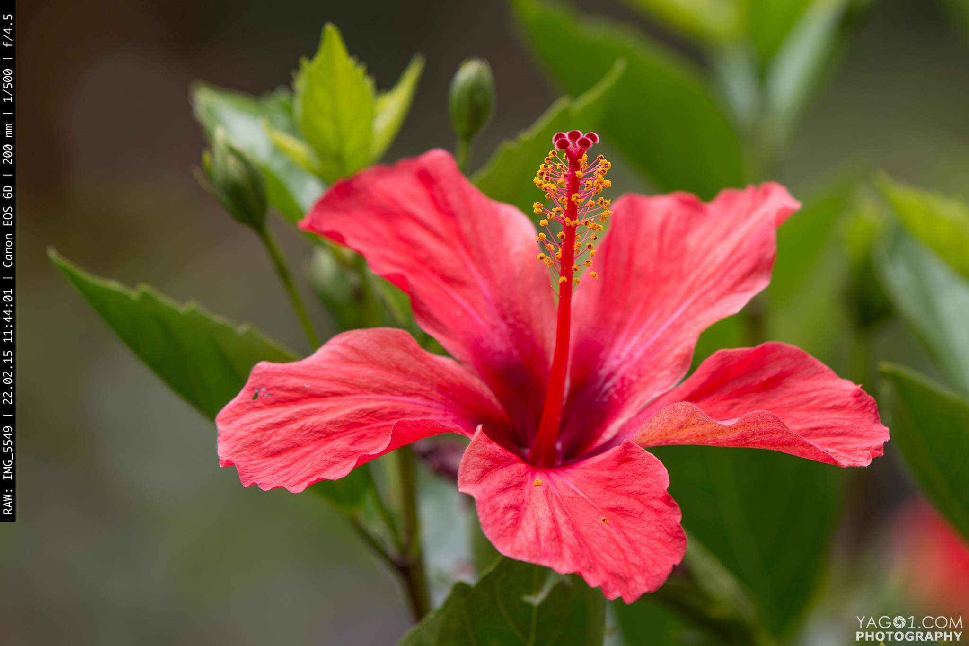
Our focus during the second half of the summer term is on rocks. The children will
compare and group together different kinds of rocks on the basis of their appearance and simple physical properties. They will describe how fossils are formed and will recognise that soils are made from rocks and organic matter.
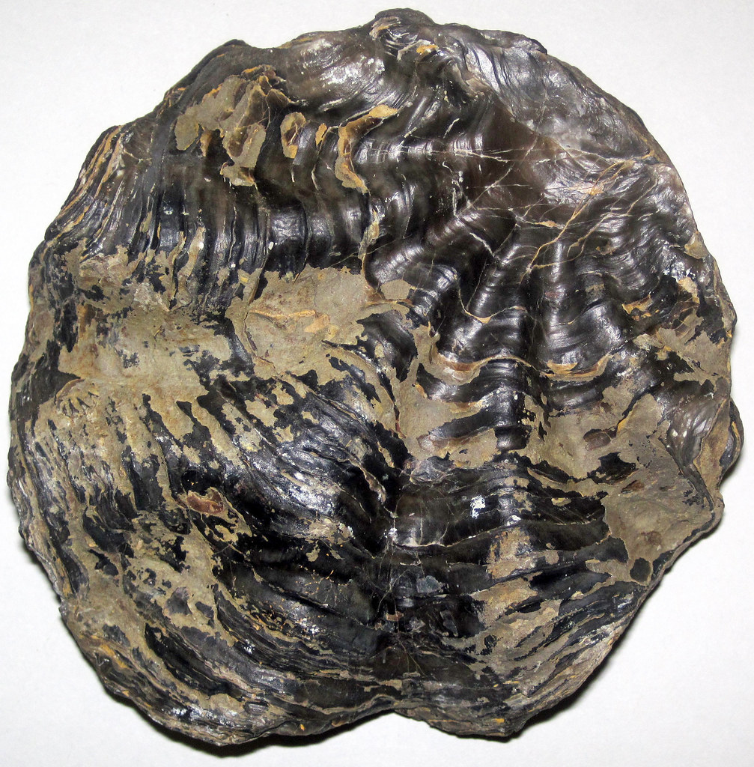

Topic
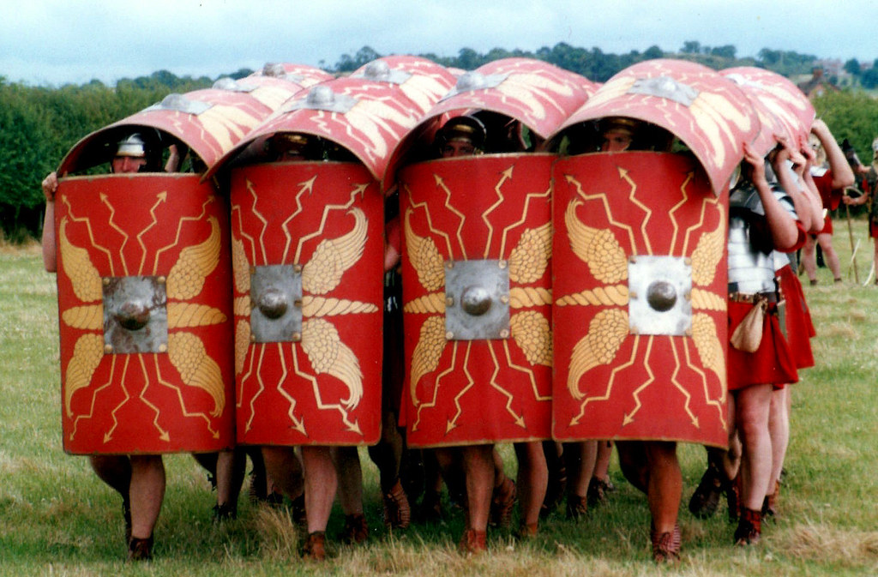
Our topic for the first half of the summer term is the history topic
‘I can tell you about the Roman occupation of Britain’. The children will learn
about the Roman Empire and its impact and legacy on Britain.

Our topic for the second half of the summer term is the geography topic ‘I
can compare my locality with another area of the United Kingdom’ (Peak District) The children will find out more about U.K counties and districts. They will consider why land is used in different ways. We will have lots of opportunities for fieldwork during our Stanley Head visit and day trip to ‘The Roaches’, in The Peak District.

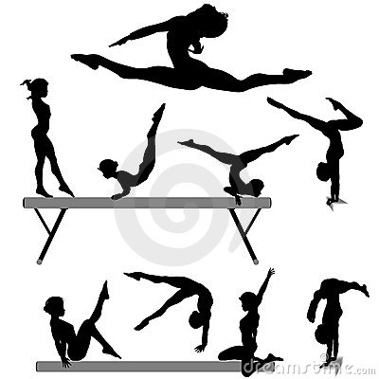
P.E
During the summer term P.E. will be every Tuesday and Friday. Please ensure your child has a full P.E kit at school, including jogging bottoms and trainers. This term in P.E our focuses will be team games (striking and hitting), athletics and outdoor and adventure activities.
Art-  Our focus in art during the first half term is printing. We will be exploring with different types of printing using a variety of materials, such as fruit and vegetables, wood blocks, lino and string. We will experiment with different styles and techniques, and explore colour mixing and overlapping.  During the second half term our focus is pattern. We will look at different patterns in the environment and will design our own patterns using different media. | Design/Technology-  This term in D/T we will firstly finish our rainforest creatures using simple pneumatic systems.  We will then focus on textiles to design and make a purse for a Roman soldier.  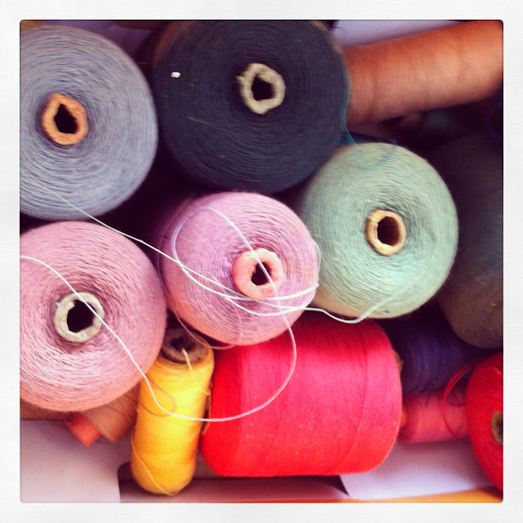 |  | Music-  We have been very lucky to secure Mr Hughes for music. The children will continue with their exciting and varied music curriculum.
RE – In R.E during the first half term we will be exploring the Creation story in the Bible and thinking about what Christians learn from it. There will be lots of opportunity for children to ask questions, discuss this and develop their own opinions and ideas. During the second half term we will consider why it is important to remember? We will be looking at ways that people from different faiths use symbols and ceremonies as a way of remembering. For example, Holy Communion in Christianity and Passover in Judaism.
Computing
Computing will be taught both explicitly and across the curriculum. This term our focus is desktop publishing and we will be using desktop publishing software and considering careful choices of font size, colour and type
to edit and improve documents.

Personal, Social and Health Education will follow themes during the year but will also be responsive to the development and needs of the children. During the summer term our focus will be on understanding the role of money in their own and other’s lives. We will understand how to manage money and to be a critical consumer. The children will learn that resources are allocated in different ways and these economic choices affect individuals, communities and the sustainability of the environment.
WATER BOTTLES/SUN HATS
The children are asked to bring a filled water bottle to school every day that is clearly labelled with their name. These bottles need to go home at the end of every day to be washed. As the weather is improving, please ensure the children have a sun cream on and a sun hat.

We can be contacted through the school office or by email for any queries or support. Our emails are mandy.heathcote@baldwinsgate.staffs.sch.uk and amanda.roche@baldwinsgate.staffs.sch.uk

